JNK Photo-Studio

**Preface**

Before Tasking The Project Work For Foundation, It Is Quite Necessary To Have An Exact Idea The Work “Project”. The Project Consist Of Seven Letters Each Letter Has Its Own Significance As Follow.

‘P‘For Planning

‘R‘ For Resource

‘O’ For Operation

‘J‘ For Joints Efforts

‘E‘ For Engineering Function

‘C‘ Communication

‘T‘ Task of Working

We Happy To Hand over This Project to The**Shree S.V Patel College Of Computer Science And Business Management.** This Project Is Online Photo Studio To Provide For Customer.

In A Computer Application Studies, The Partial Training Is Very Important. We Can Improve Theoretical Knowledge By Reading And Attempt Class But It Is Imperfect Without Getting Partial Knowledge. Begin an It Student, We Should See Every Side Of Technical Unit. It Perform Vital Role In Developing Software And Situation Opportunities And Problem.

Here, We Are Presenting A Project On The Different Concept Which We Saw, Fell, & Experience While The Training In The Organization. We Have Tried Our Level Best To Do Proper Justification With Our In This Project.

**ACKNOWLEDGEMENT**

Our Self**Mr.Rokad Neel B.&Mr.Ramani Jaydip M**.**&Mr.Kaklotar Kevel V.** Have Opportunity To Express Our Knowledge. We Would Like To Express Our Gratitude To All Those Who Gave Us The Possibility To Complete Our Project.

Success Is Such A Comprehensive Project Can Not Achieved Single-Handed. It Is Team Effort That Sails The Ship To The Coast. So We Would Like To Express Our Sincere Thanks To All The Dignitaries Who Were Involve In Making This Project The Great Joy And Turning It Our Into Successful Piece Of Work.

**DR RadhikaAmlani** – Our Professor And Project Co-ordinates Has Been Very Prudent To Us Threw Out The Collage Studies. They Are The Person Who Has Giving This Direction To Our Work And The Shape To Our Imagination. We Express Our Regard To Them From The Core Of Our Heart. We Also Like To Thanks Our All The Professor Who Are Always Ready To Give Best Guide. They Are The Person Who Give Solution Whenever Needed.

We Would Also Like To Acknowledge All The Friends And Colleagues, Team Member For The Help And Encouragement By Them For Time To Time. The Constant Support And Encouragement Of My Friend Is Deeply Appreciates. The Project Indeed Gave Challenging And Exhilarating Experience In Designing And Developing The Required System.

From,

Rokad Neel B.

Ramani Jaydip M.

Kaklotar Kevel V.

Index

|  |  |  |
| --- | --- | --- |
| Sr.No | Particular | Page No |
| 1. | Introduction   * 1. Project Profile   2. Project Introduction |  |
| 2. | Environment Description  2.1 Hardware & Software Requirement  2.2 Technology Used |  |
| 3. | Problem Specification  3.1 System Model  3.2 Drawback Of Existing System |  |
| 4. | System Planning   * 1. Feasibility Study   2. Requirement Analysis And Data Gathering |  |
| 5. | Proposed System  5.1 Scope  5.2 Objective  5.3 Constraints  5.4 Expected Advantages |  |
| 6. | Details Planning  6.1 Data Flow Diagram  6.2 Time Line Chart  6.3 Data Dictionary  6.4 Entity Relation Diagram |  |
| 7. | System Design  7.1 Database Design  7.2 Input/Output Design |  |
| 8. | Software Testing |  |
| 9. | Limitation And System Enhancement |  |
| 10. | Bibliography |  |

**1. Introduction**

**1.1 Project Profile**

**1.2 Project Introduction**

**1.1 Project Profile**

|  |  |
| --- | --- |
| Project Name: | JNK Photo-Studio |
| Technology: | PHP,MySQL |
| Front End: | Codeigniter(CI) |
| Back End: | MySQL |
| Internal Guide: | Dr.RadhikaAmlani |
| Submitted To: | Shree S.V Patel College Of Computer Science And Business Management. |
| Developed By: | Rokad Neel B.  Ramani Jaydip M.  Kaklotar Kevel V. |

**1.2 Project Introduction**

**Project Title:** “JNK Photo-Studio”

**Project Definition:**

The project entitled “JNK Photo-Studio” (also known as a photography studio or photo art lab) is a website to make a different types of albums with different categories. Photo capturing/editing by different types of specialist of photographers.

**Features:**

Appointment Scheduling

Album Category Manage

Client Manage

Contract Manage

Price-List Manage

Client Login Manage

Email Manage

**2. Environment Description**

**2.1 Hardware& Software Requirement**

**2.2 Technology Used**

**2.1 Hardware& Software Requirement**

|  |  |
| --- | --- |
| Software | WAMP server |
| Operating System | Windows 10 |
| Database | MySQL |
| Memory | 4 GB |
| Disk space | 1 TB |

**2.2 Technology Used**

**Over View of PHP**

* PHP started out as a small open source project that evolved as more and more people found out how useful it was. Rasmus Lerdorf unleashed the first version of PHP way back in 1994.
* PHP is a recursive acronym for "PHP: Hypertext Preprocessor".
* PHP is a server side scripting language that is embedded in HTML. It is used to manage dynamic content, databases, session tracking, even build entire e-commerce sites.
* It is integrated with a number of popular databases, including MySQL, PostgreSQL, Oracle, Sybase, Informix, and Microsoft SQL Server.
* PHP is pleasingly zippy in its execution, especially when compiled as an Apache module on the Unix side. The MySQL server, once started, executes even very complex queries with huge result sets in record-setting time.
* PHP supports a large number of major protocols such as POP3, IMAP, and LDAP. PHP4 added support for Java and distributed object architectures (COM and CORBA), making n-tier development a possibility for the first time.
* PHP is forgiving: PHP language tries to be as forgiving as possible.



**Common Uses Of PHP**

* PHP performs system functions, i.e. from files on a system it can create, open, read, write, and close them.
* PHP can handle forms, i.e. gather data from files, save data to a file, through email you can send data, return data to the user.
* You add, delete, modify elements within your database through PHP.
* Access cookies variables and set cookies.
* Using PHP, you can restrict users to access some pages of your website.
* It can encrypt data.

## Features of PHP

**SIMPLE**

**FLEXIBILITY**

**EFFICIENCY**

**SIMPLICITY**

**INTERPRETED**

**PLATFORM INDEPENDENT**

**MORE FASTER**

**OPEN SOURCE**

It is most popular and frequently used world wide scripting language, the main reason of popularity is; It is open source and very simple.

* Simple
* Faster
* Interpreted
* Open Source
* Case Sensitive
* Simplicity
* Efficiency
* Platform Independent
* Security
* Flexibility
* Familiarity

### Simple

It is very simple and easy to use, compare to other scripting language it is very simple and easy, this is widely used all over the world.

### Interpreted

It is an interpreted language, i.e. there is no need for compilation.

### Faster

It is faster than other scripting language e.g. asp and jsp.

### Open Source

Open source means you no need to pay for use php, you can free download and use.

### Platform Independent

PHP code will be run on every platform, Linux, Unix, Mac OS X, Windows.

### Case Sensitive

PHP is case sensitive scripting language at time of variable declaration. In PHP, all keywords (e.g. if, else, while, echo, etc.), classes, functions, and user-defined functions are NOT case-sensitive.

**Over View of MySQL**

### What is Database?

A database is a separate application that stores a collection of data. Each database has one or more distinct APIs for creating, accessing, managing, searching and replicating the data it holds.

Other kinds of data stores can also be used, such as files on the file system or large hash tables in memory but data fetching and writing would not be so fast and easy with those type of systems.

Nowadays, we use relational database management systems (RDBMS) to store and manage huge volume of data. This is called relational database because all the data is stored into different tables and relations are established using primary keys or other keys known as **Foreign Keys**.

A **Relational Database Management System (RDBMS)** is a software that −

* Enables you to implement a database with tables, columns and indexes.
* Guarantees the Referential Integrity between rows of various tables.
* Updates the indexes automatically.
* Interprets an SQL query and combines information from various tables.

## RDBMS Terminology

Before we proceed to explain the MySQL database system, let us revise a few definitions related to the database.

* **Database** − A database is a collection of tables, with related data.
* **Table** − A table is a matrix with data. A table in a database looks like a simple spreadsheet.
* **Column** − One column (data element) contains data of one and the same kind, for example the column postcode.
* **Row** − A row (= tuple, entry or record) is a group of related data, for example the data of one subscription.
* **Redundancy** − Storing data twice, redundantly to make the system faster.
* **Primary Key** − A primary key is unique. A key value cannot occur twice in one table. With a key, you can only find one row.
* **Foreign Key** − A foreign key is the linking pin between two tables.
* **Compound Key** − A compound key (composite key) is a key that consists of multiple columns, because one column is not sufficiently unique.
* **Index** − an index in a database resembles an index at the back of a book.
* **Referential Integrity** − Referential Integrity makes sure that a foreign key value always points to an existing row.

## C:\Users\abc\Documents\php-mysql-icon.png

## MySQL Database

MySQL is a fast, easy-to-use RDBMS being used for many small and big businesses. MySQL is developed, marketed and supported by MySQL AB, which is a Swedish company. MySQL is becoming so popular because of many good reasons −

* MySQL is released under an open-source license. So you have nothing to pay to use it.
* MySQL is a very powerful program in its own right. It handles a large subset of the functionality of the most expensive and powerful database packages.
* MySQL uses a standard form of the well-known SQL data language.
* MySQL works on many operating systems and with many languages including PHP, PERL, C, C++, JAVA, etc.
* MySQL works very quickly and works well even with large data sets.
* MySQL is very friendly to PHP, the most appreciated language for web development.
* MySQL supports large databases, up to 50 million rows or more in a table. The default file size limit for a table is 4GB, but you can increase this (if your operating system can handle it) to a theoretical limit of 8 million terabytes (TB).
* MySQL is customizable. The open-source GPL license allows programmers to modify the MySQL software to fit their own specific environments.

## Sublime Text 3



Sublime Text 3 is an amazing piece of software. To start, it is a clean, functional, and fast code editor. Not only does it have incredible built in features (multi-edit and vim mode), but it has support for plugins, snippets, and many other things.

I know there have already been many articles like this online, but I am teaching a class on Sublime Text and thought it would be good to have all the information online. In this article, we'll be diving into the best parts of Sublime Text. You've probably already heard of some of these, but maybe not some others.

## Codeigniter:



CodeIgniter is an application development framework, which can be used to develop websites, using PHP. It is an Open Source framework. It has a very rich set of functionality, which will increase the speed of website development work.

If you know PHP well, then CodeIgniter will make your task easier. It has a very rich set of libraries and helpers. By using CodeIgniter, you will save a lot of time, if you are developing a website from scratch. Not only that, a website built in CodeIgniter is secure too, as it has the ability to prevent various attacks that take place through websites

**3. Problem Specification**

**3.1System Components**

**3.2 Drawbacks of Existing System**

**3.1 System Component**

This system content some components which make r\the current system

able to provide the better facility than the existing one .

* **Manage Admin:**

It is an Admin side interface and also includes the new

registration facility to add new doctors by setting their specific role into the

system. By specifying the role the administrator also specifies the privileges of

each tutorial into the system. The interface also includes the profile

Management of each and every tutorial of the system.

* **Manage database:**

This component refers to management of the content within the backend.

This is an important component as it servers the fooding of the website.

The content which the website provides to its user decides the usage

and satisfactory performance of the system

* **Course management:**

This system will manage the course, this allow an admin to

add,update,delete course & sub course.

* **Faculty management:**

This system will manage the Faculty, this allow an admin to

add ,update,delete Faculty.

**3.2 Drawbacks of existing system**

* Graphics issue
* Photographer payment issue
* Only for specific area
* Security level is low
* Lack of security
* Cash on delivery is not available

**4. System Planning**

* 1. **Feasibility Study**
  2. **Requirement Analysis And Data Gathering**

**4.1 Feasibility Study**

**Introduction**

A feasibility study is an evaluation and analysis of the potential of the proposed project which is based on extensive investigation and research to give full comfort to the decisions makers.

**1. Economical Feasibility**

**2. Technical Feasibility**

**3. Behavioral and operational feasibility**

**1. Economical Feasibility**

* In economical way the proposed system had no problems because this entire necessary infrastructure required for the proposed system was readily available and no new investment as such was required.
* Developed system is user friendly and interactive so that user doesn’t require any training to use this friendly and interactive so that user doesn’t require any training to use this system.

**2. Technical Feasibility**

* The technical requirements for the proposed system are of necessary computer hardware and software.
* “The company” was having computer facilities, which satisfy the hardware requirements and software requirements were also met by it.

**3. Behavioral and Operational Feasibility**

* The change in the existing system was desired by management and hence staff has to accept it, but it was necessary to feel the pulse of the staff that was actually going to use proposed system.
* The staff was properly explained as to why the change was needed and how it would benefit them in their daily routine.
* They were made to realize that the proposed system would be more convenient to them. This changed their thoughts towards the proposed system.

**4.2 Requirement Analysis And Data Gathering**

* **Requirement gathering**
* For requirement gathering of our project we had studied existing online Photo-Studio platforms like **Weddingnama.com**, **phototantra.com**, **shitalstudio.com**,**shutterdown.com**etc.,
* We had further studied on its functionalities and features.
* We also noticed graphical interface and responsive design for every type of devices.
* **Understanding the process of security system**
* How to manage all forms?
* How to manage login and logout process?
* How to manage all forms are linked with each other.
* How to manage intercommunication with internet?
* How to manage the bunch of data of particular member so that it can have the security purpose and keep the data private.
* How to perform all users security level and perform an authentication and give person account to each member for security purpose.
* **Understanding different types of user who user this website**
* How many users are going to use this website?
* Provide an authentication and separate their functionality
* **Requirement analysis**

We analyzed our gathered information and we have decided our system should have following functionalities:

* **Authentication of users**
* Creation of user account
* Deletion of user account
* Authorization of user account
* **Different types of module**
* Login
* Client management
* Album management
* Registered user management
* **Registered user**
* Login
* Take Appointment
* Choose Photographer
* Get Album
* **Admin**
* User management
* Seller management
* Product management
* Attribute management

**5. Proposed System**

**5.1 Scope**

**5.2 Objective**

**5.3 Constraints**

**5.4 Expected Advantages**

**5.1 Scope**

The current project of**JNK Photo-Studio**we have undertaken, the corresponding scope of our intranet application is as follows: For

* + - * This is a user friendly layout & easy to understand for every users or visitors.
      * Website can able to manage the member and also their album details of client online.
      * It will allow user to recover password.
      * It will allow user to Give feedback.
      * It is able to Give information of registered users and also edit that information.
      * It allows sending mails.

**5.2 Objective**

* This project is satisfied a customer need thought and feedback services.
* Store every data in form of records as a softcopy so as to reduce storage spaces and also reduce manual date entry errors.
* To make work faster.
* To be modernize the work of organization.
* Maintain databases so that data can be easily consuming less time and efforts.
* To simplify the query process.
* Minimize the data redundancy.
* To adopt new technology.
* Provide the accurate and relevant information.
* Enhanced data integrity.
* To provide the complete security mechanism.
* Save time, storage spaces and fast processing.
* To create an interactive database.

**5.3 Constraints**

The constraint associated in the development of any system includes those that are common to all system. The common constraints may include frequent change in requirements of the managements etc. We have also experience similar types of constraints listed above and others.

Some of the constraints are listed below with which we have developed this sites is requires.

* + - User can visit this Site easily or understand easily.
    - To establish a visitor database.
    - To gain a competitive advantage.
    - To learn more about your customers.
    - Allow the visitors for register of this site.
    - Secure transaction.
    - To improve visitor relationships through personalization.

**5.4 Expected Advantage**

* **High security**

There is high security mechanism provide by the proposed system. No authorized person can make change in data those are stored in website. Only authorized person can change & also can make login.

* **Less time required**

In our website, all the process are carried out by computer so obviously it will require time than traditional inventory system and it that sense; it will require less to complete transaction and can data process data very fast.

* **High amount of accuracy**

In our web system there are less amount of human activities are involved in that case it will have less effect in our accounts. The website will perform all calculation and manipulation automatically; In that case the data that receive will be accurate ad much more reliable than the data that generated previously.

* **Easy to use**

Fashionhub is accessible round the clock. You can buy the product of your choice even at 2 a.m. in the morning. You can choose from a wider variety of things available for you to shop which may not available in the local brick and mortar store. When you buy from online store you have the comfort to take your time while checking for the things of your choice.

* **Reduce the paper work**

All the work done by the computerized system. So, all the paper work will be remove.

**6.Details Planning**

**6.1 Data Flow Diagram**

**6.2 Time Line Chart**

**6.3 Data Dictionary**

**6.4 Entity Relation Diagram**

**6.1 Data flow diagram**

The data flow diagrams are an intuitive way of the showing how data is processed by a system. The symbols used in DFD for this project are shown below.

* **Data flow**

Following symbol is used to show data flow. The data flow is packet of data

* **Process**

People, procedures of device that use or produce data.

* **Source or Destination or Data**

These are the entities, which interact with the system from outside its boundaries.

* **Data storage**

Here data are stored or referenced process in the system.

In DFD diagram we defined the flow of data and how the system data flow managed by grouping the data with the entity relationship. In this way we find out the need of the system and managed it in particular way by which we can easily access with system.

By the use of DFD diagram all the complete data flow is understood by the system analysis. Here in our DFD there is a once the patient is going for treatment the management of hospital first inform the patient that which kind of treatment is available and what kind of task is performed by the person and which kind of function should be Implemented by the management person who is managing

* **Context Leval Diagram For A Photo-Studio**

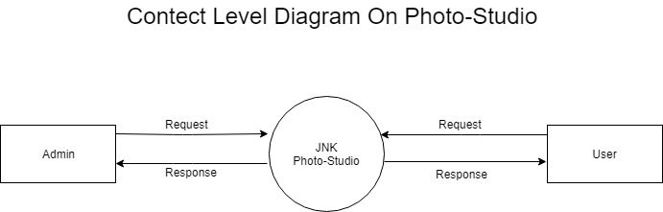

* **ZeroLeval Diagram For A Photo-Studio**

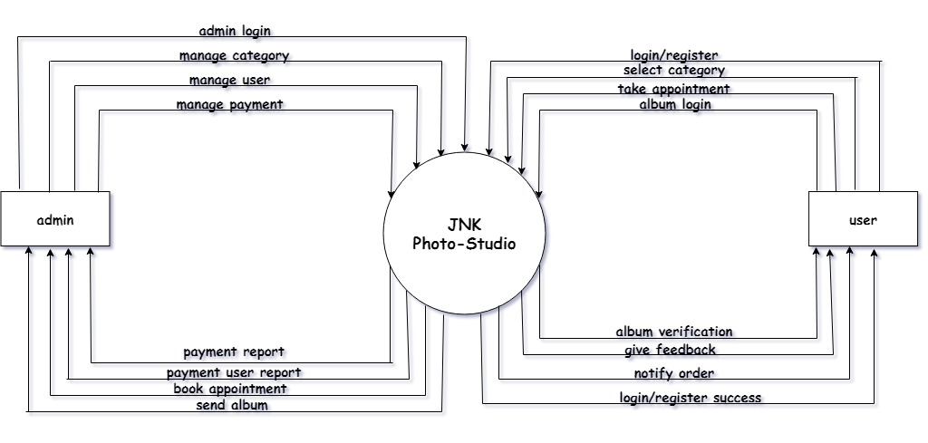

* **1stLeval Diagram For A Photo-Studio**

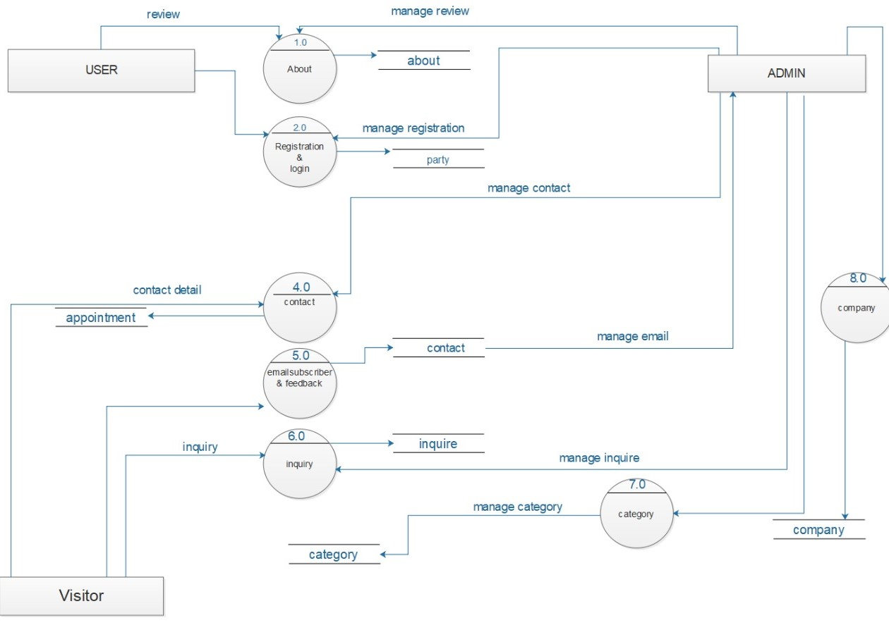

**6.2 Time Line Chart :**

|  |  |  |  |  |  |  |  |  |  |  |  |  |  |  |  |  |  |  |  |  |  |  |  |  |  |  |  |  |
| --- | --- | --- | --- | --- | --- | --- | --- | --- | --- | --- | --- | --- | --- | --- | --- | --- | --- | --- | --- | --- | --- | --- | --- | --- | --- | --- | --- | --- |
|  | **January** | | | | | | **february** | | | | | | | **march** | | | | | | | **april** | | | | | | | |
| Requirement gathering |  |  |  |  |  |  |  |  |  |  |  |  |  |  |  |  |  |  |  |  |  |  |  |  |  |  |  |
| Feasibility study |  |  |  |  |  |  |  |  |  |  |  |  |  |  |  |  |  |  |  |  |  |  |  |  |  |  |  |
| analysis |  |  |  |  |  |  |  |  |  |  |  |  |  |  |  |  |  |  |  |  |  |  |  |  |  |  |  |
| Design |  |  |  |  |  |  |  |  |  |  |  |  |  |  |  |  |  |  |  |  |  |  |  |  |  |  |  |
| Coding |  |  |  |  |  |  |  |  |  |  |  |  |  |  |  |  |  |  |  |  |  |  |  |  |  |  |  |
| Testing |  |  |  |  |  |  |  |  |  |  |  |  |  |  |  |  |  |  |  |  |  |  |  |  |  |  |  |
| implementation |  |  |  |  |  |  |  |  |  |  |  |  |  |  |  |  |  |  |  |  |  |  |  |  |  |  |  |

**6.3 Data Dictionary**

**About :**

|  |  |  |  |
| --- | --- | --- | --- |
| Field Name | Type | Constraints | Description |
| about_id | int(11) | Primary Key | Auto increment. |
| name | varchar(30) | Not null | It content name to about table. |
| desc | text | Not null | It content description to about table. |

**Admin-Login :**

|  |  |  |  |
| --- | --- | --- | --- |
| Field Name | Type | Constraints | Description |
| login_id | Int(11) | Primary Key | Auto increment. |
| admin_user | Varchar(40) | Not null | It used to enter a admin name. |
| admin_pass | Varchar(50) | Not null | It used to enter a admin password for login. |

**Appointment :**

|  |  |  |  |
| --- | --- | --- | --- |
| Field Name | Type | Constraints | Description |
| appointment_id | Int(11) | Primary Key | Auto increment. |
| name | Varchar(30) | Not null | It contents client’s name to appointment table. |
| email | Varchar(50) | Not null | It contents client’s email to appointment table. |
| mobile | Varchar(50) | Not null | It contents client’s mobile number to appointment table. |
| msg | text | Not null | It used to send any type of message to client. |
| speciality | Varchar(50) | Not null | It shows the speciality of a photographers. |
| photo_name | Varchar(60) | Not null | It display a selected photographer’s name. |
| date_time | datetime | Not null | It select a date and time for a appointment. |
| status | Varchar(30) | Not null | It used to send a confirmation and cancellation message. |

**Category :**

|  |  |  |  |
| --- | --- | --- | --- |
| Field Name | Type | Constraints | Description |
| category_id | int(50) | Primary key | Auto increment. |
| name | Varchar(30) | Not null | It displays a name of different categories. |
| image | text | Not null | It displays a name of different categories images. |

**Company :**

|  |  |  |  |
| --- | --- | --- | --- |
| Field Name | Type | Constarints | Description |
| company_id | int(11) | Primary Key | Auto increment. |
| name | Varchar(30) | Not null | It displays a name of company. |
| email | Varchar(30) | Not null | It displays email of company. |
| mobile | Varchar(15) | Not null | It displays mobile number of company. |
| address | text | Not null | It displays address of company. |
| timing | Varchar(30) | Not null | It displays timing of company. |

**Contact :**

|  |  |  |  |
| --- | --- | --- | --- |
| Field Name | Type | Constraints | Description |
| contact_id | int(11) | Primary Key | Auto increment. |
| email | Varchar(30) | Not null | It gets a user’s email to admin. |
| msg | text | Not null | It sends a user feedback to admin. |
| name | Varchar(30) | Not null | It displays a user user’s name to admin. |
| mobile | Varchar(15) | Not null | It displays a user user’s mobile number to admin. |

**Gallery :**

|  |  |  |  |
| --- | --- | --- | --- |
| Field Name | Type | Constraints | Description |
| gallery_id | int(11) | Primary Key | Auto increment. |
| name | Varchar(40) | Not null | It displays a category name. |
| Category_id | Int(11) | Foreign Key | Auto increment. |
| image | text | Not null | It displays a category wise images . |

**Inquery :**

|  |  |  |  |
| --- | --- | --- | --- |
| Field Name | Type | Constraints | Description |
| inquery_id | int(11) | Primary Key | Auto increment. |
| Category_id | int(10) | Foreign Key | Auto increment. |
| name | Varchar(40) | Not null | It is use to shows name of the user |
| date | date | Not null | It shows the date of appointment |
| status | Varchar(15) | Not null | It shows the feedback of user |
| location | text | Not null | It shows location of the user |

**Master :**

|  |  |  |  |
| --- | --- | --- | --- |
| Field Name | Type | Constraints | Description |
| master_id | int(11) | Primary Key | Auto increment. |
| Category_id | int(11) | Foreign Key | Auto increment. |
| party_id | int(11) | Foreign Key | Auto increment. |
| password | Varchar(50) | Not null | It generates a security Key for a album. |
| image | text | Not null | It displays a album images. |

**Party :**

|  |  |  |  |
| --- | --- | --- | --- |
| Field Name | Type | Description | Description |
| party_id | int(11) | Primary Key | Auto increment. |
| name | Varchar(40) | Not null | It displays a party’s name. |
| Category_id | int(11) | Foreign Key | Auto increment. |
| address | text | Not null | It displays a party’s address. |
| mobile | Varchar(15) | Not null | It displays a party’s mobile number. |
| email | Varchar(30) | Not null | It displays a party’s email. |
| date | date | Not null | It displays a date of appointment. |
| password | Varchar(50) | Not null | It displays a party’s security Key. |

**Photographer_info :**

|  |  |  |  |
| --- | --- | --- | --- |
| Field Name | Type | Constraints | Description |
| Photographer_info_id | int(11) | Primary Key | Auto increment. |
| name | Varchar(30) | Not null | It displays a different photographer’s name. |
| address | text | Not null | It displays a company’s address. |
| mobile | Varchar(50) | Not null | It displays a photographer’s mobile number. |
| email | Varchar(50) | Not null | It displays a photographer’s email. |
| speciality | Varchar(60) | Not null | It displays a different photographer’s speciality. |

**Price_list :**

|  |  |  |  |
| --- | --- | --- | --- |
| Field Name | Type | Constraints | Description |
| price_id | int(11) | Primary Key | Auto increment. |
| Category_id | int(11) | Foreign Key | Auto increment. |
| Size_id | int(11) | Foreign Key | Auto increment. |
| rate | Varchar(10) | Not null | It display a album rate. |

**Size :**

|  |  |  |  |
| --- | --- | --- | --- |
| Field Name | Type | Constraints | Description |
| size_id | int(11) | Primary Key | Auto increment. |
| Category_id | int(11) | Foreign Key | Auto increment. |
| Size | varchar(30) | Not null | It displays a size-list for an album. |
| rate | Varchar(10) | Not null | It displays a rate-list for an album. |

**Slider :**

|  |  |  |  |
| --- | --- | --- | --- |
| Field Name | Type | Constraints | Description |
| slider_id | int(11) | Primary Key | Auto increment. |
| name | varchar(11) | Not null | It displays a slider images name. |
| image | text | Not null | It displays an image of a slider. |

**Video :**

|  |  |  |  |
| --- | --- | --- | --- |
| Field Name | Type | Description | Description |
| video_id | int(11) | Primary Key | Auto increment. |
| category_id | int(11) | Foreign Key | Auto increment. |
| name | varchar(50) | Not null | It displays a video’s category name. |
| image | text | Not null | It displays a video’s category wise image . |

* 1. **ER Diagram For A Photo-Studio**

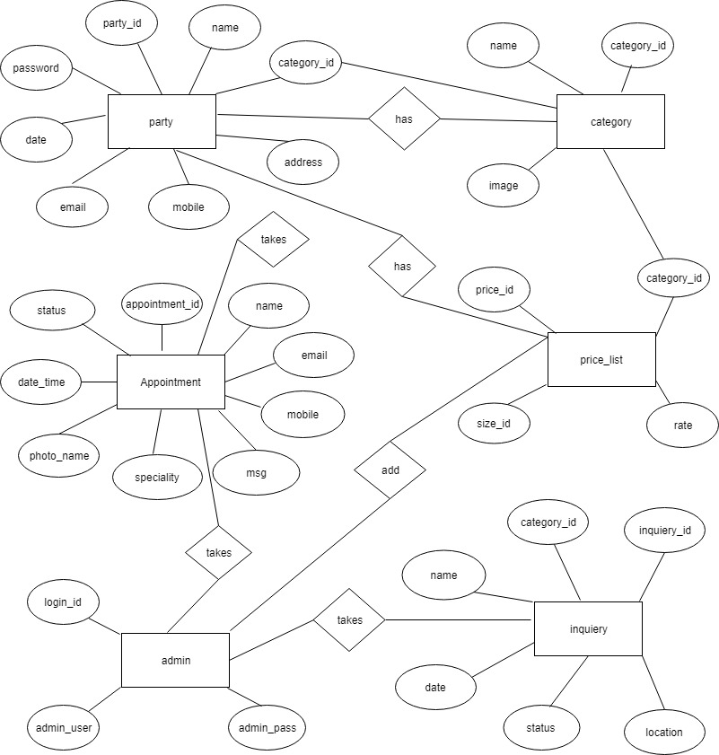

**7. System Design**

**7.1 Database Design**

**7.2 Input/Output Design**

**7.1 Database Design**

**\* Admin**

**1. Admin Login**

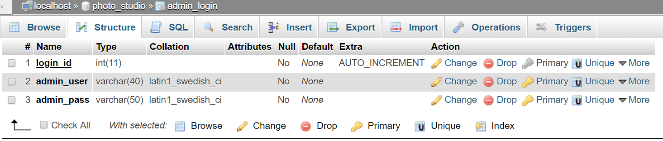

**2. Category**

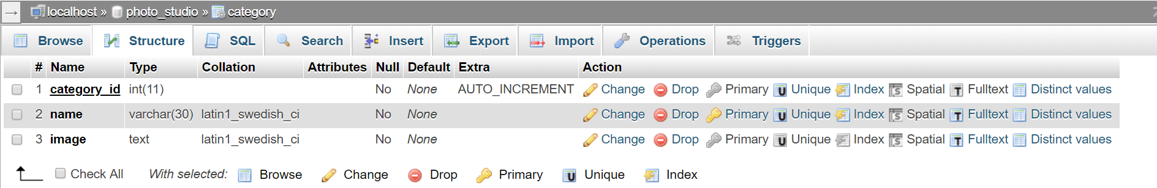

**3. Gallery**

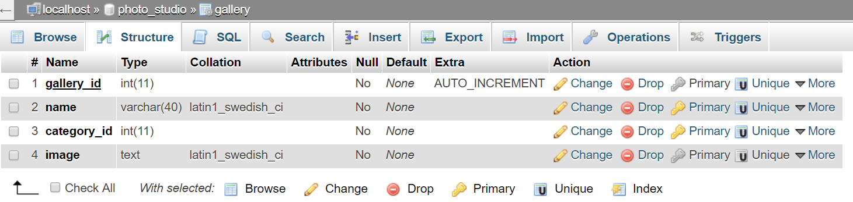

**4. About**

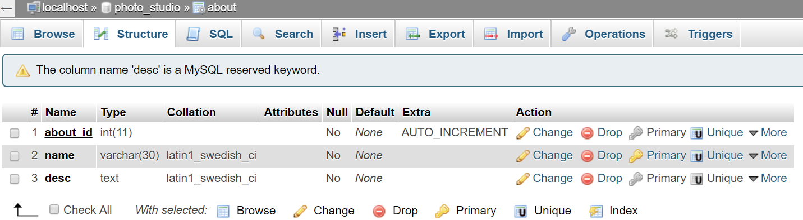

**5. Company Info.**

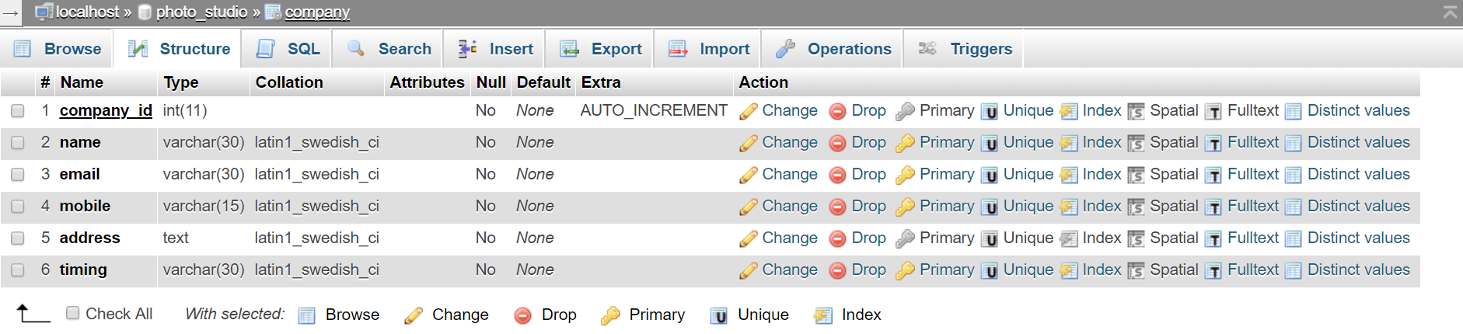

**6. Slider**

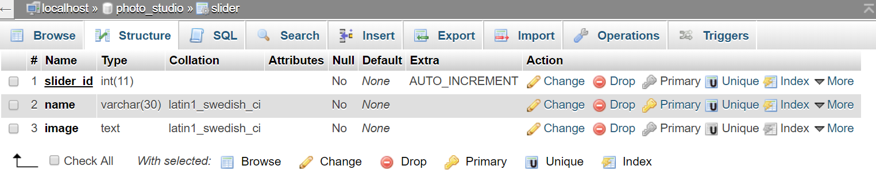

**7. Video**

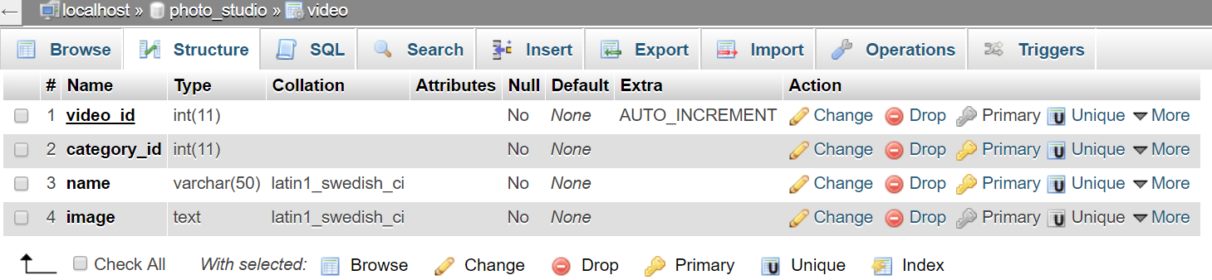

**8. Party Master**

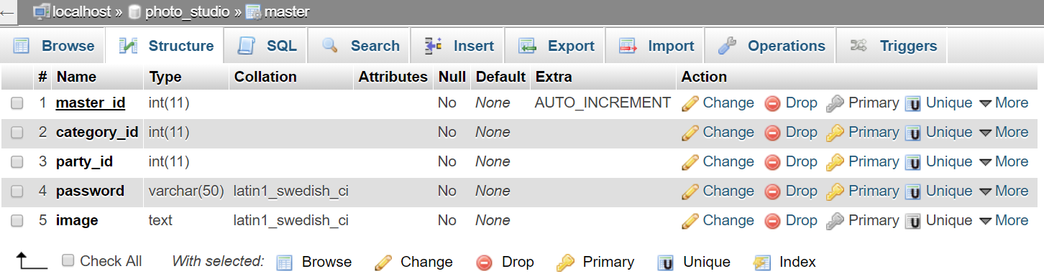

**9. Register Data**

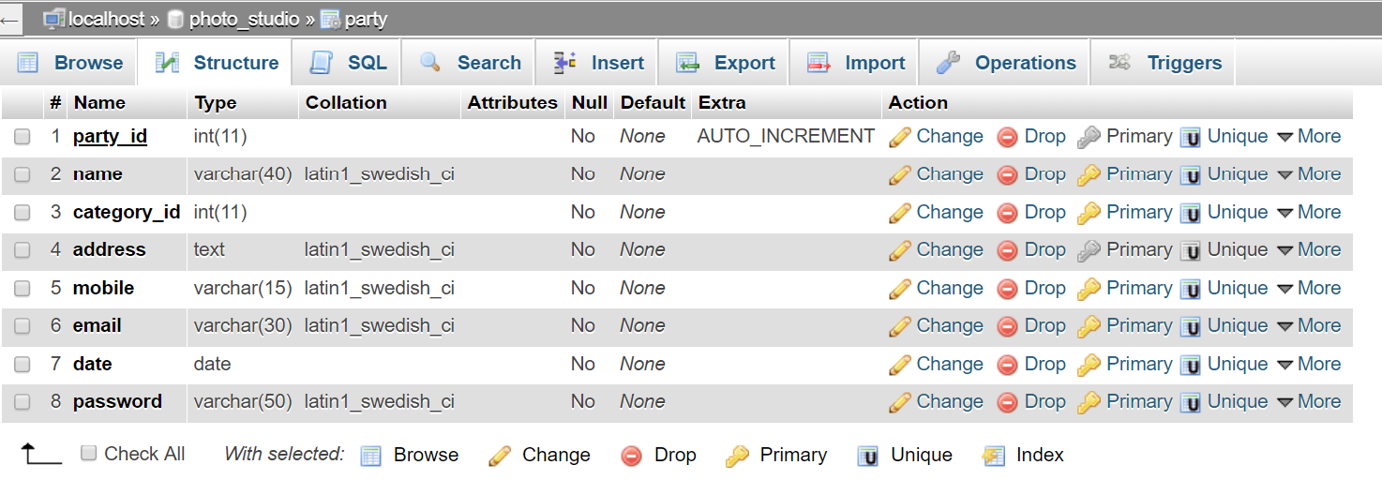

**10. Contact Data**

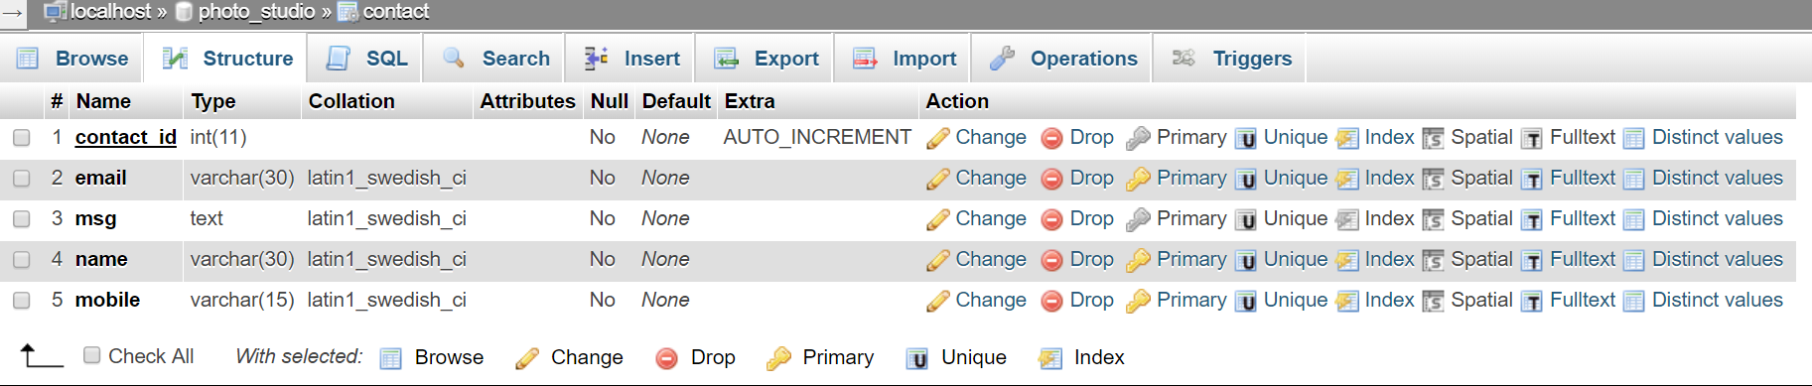

**11. Appointment Data**

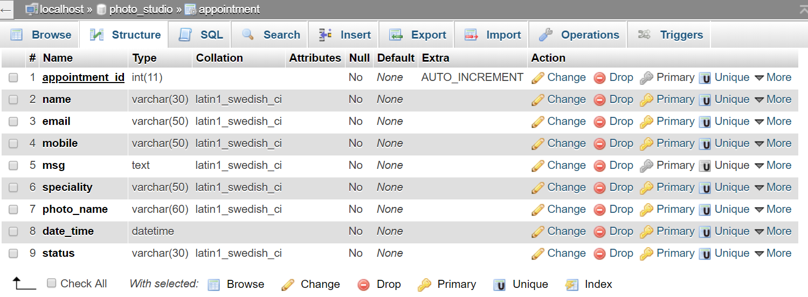

**12. Size**

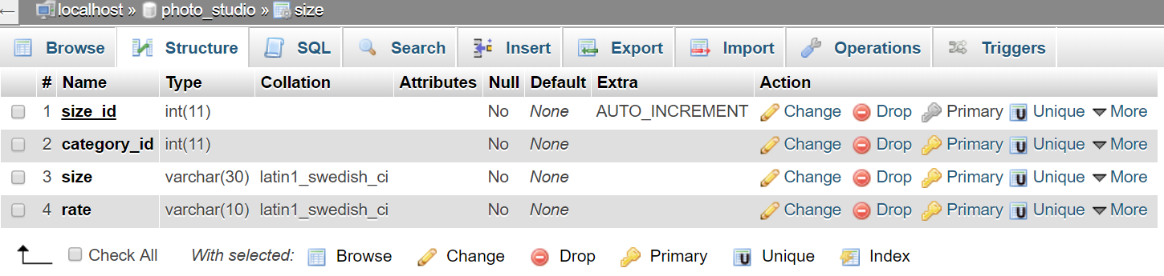

**13. Photographer Info.**

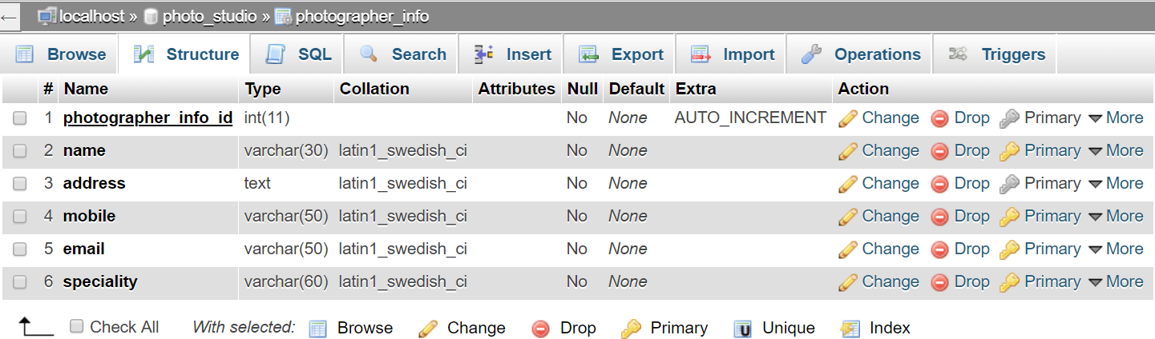

**14. Price-List**

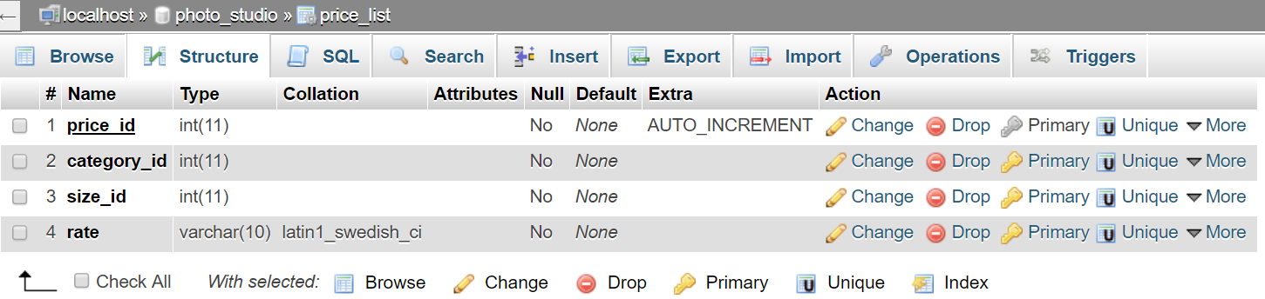

**7.2 Input/Output Design**

**1. Admin Login**

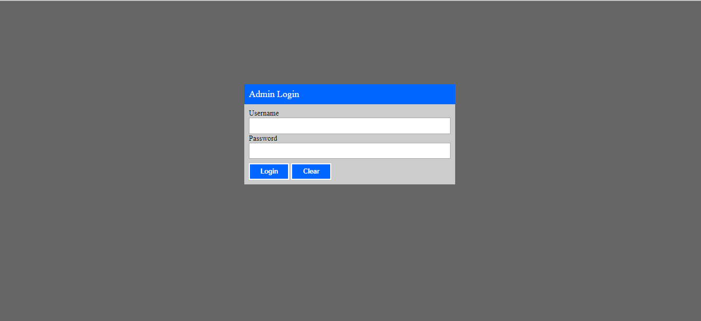

**2. Admin Login With Validation**

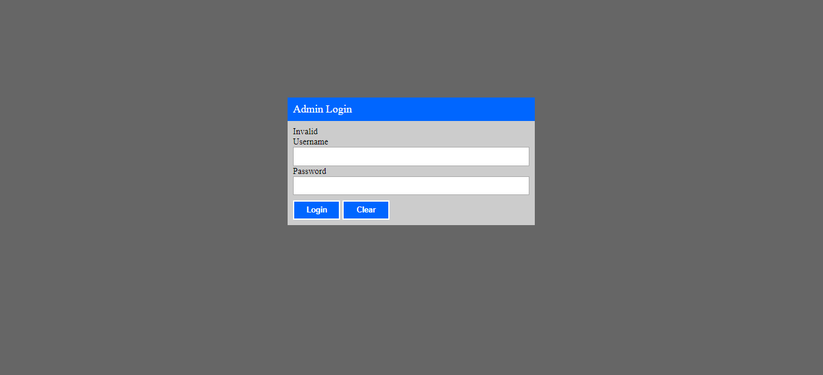

**3. Admin Category With Validation**

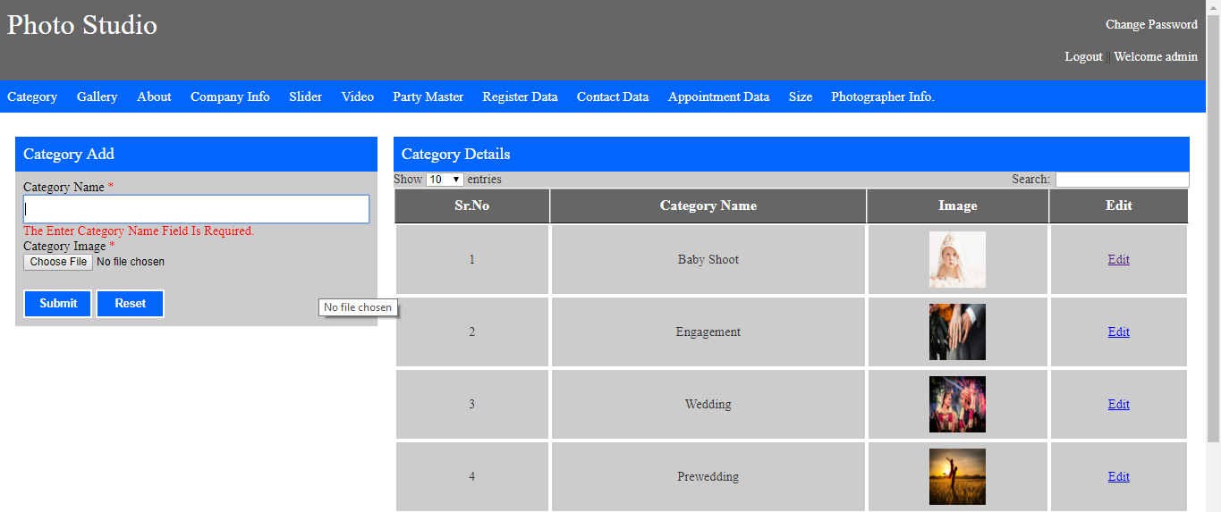

**4. Admin Gallery With Validation**

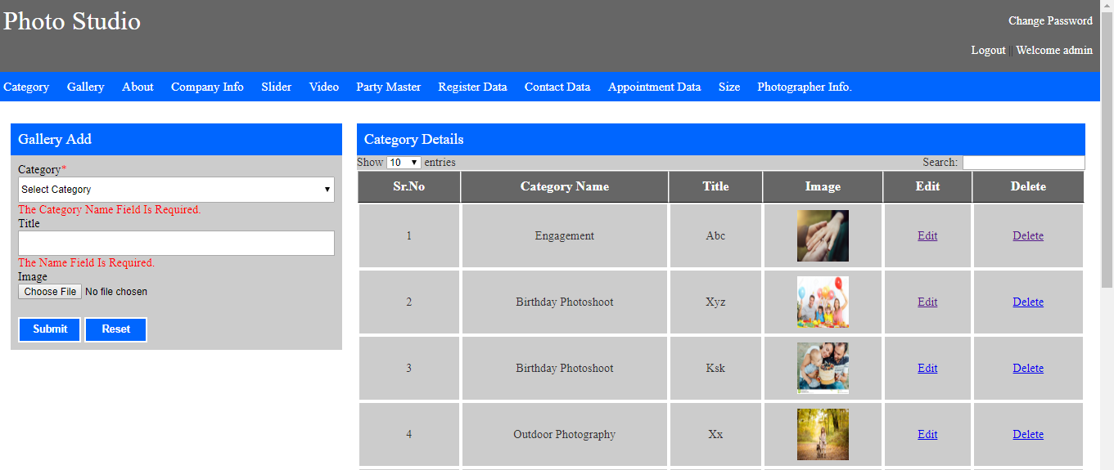

**5. Admin About With Validation**

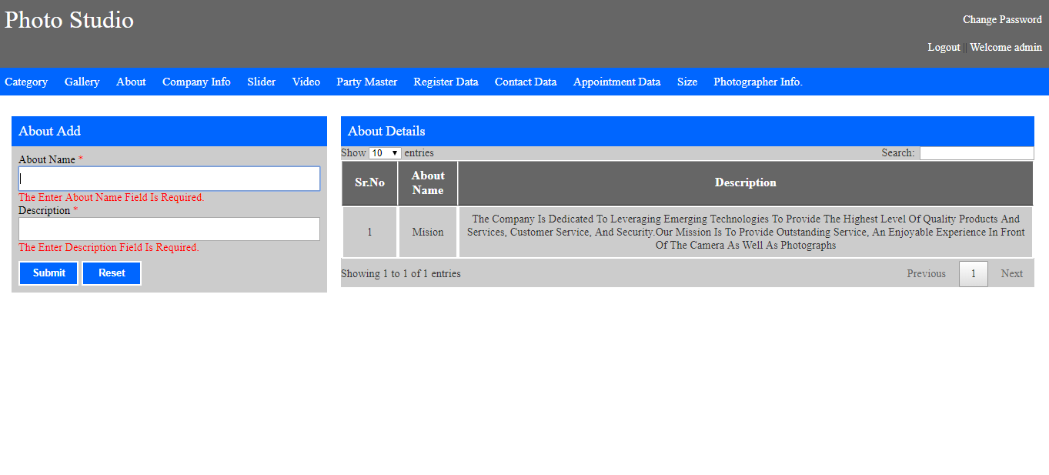

**6. Admin Company_Info. With Validation**

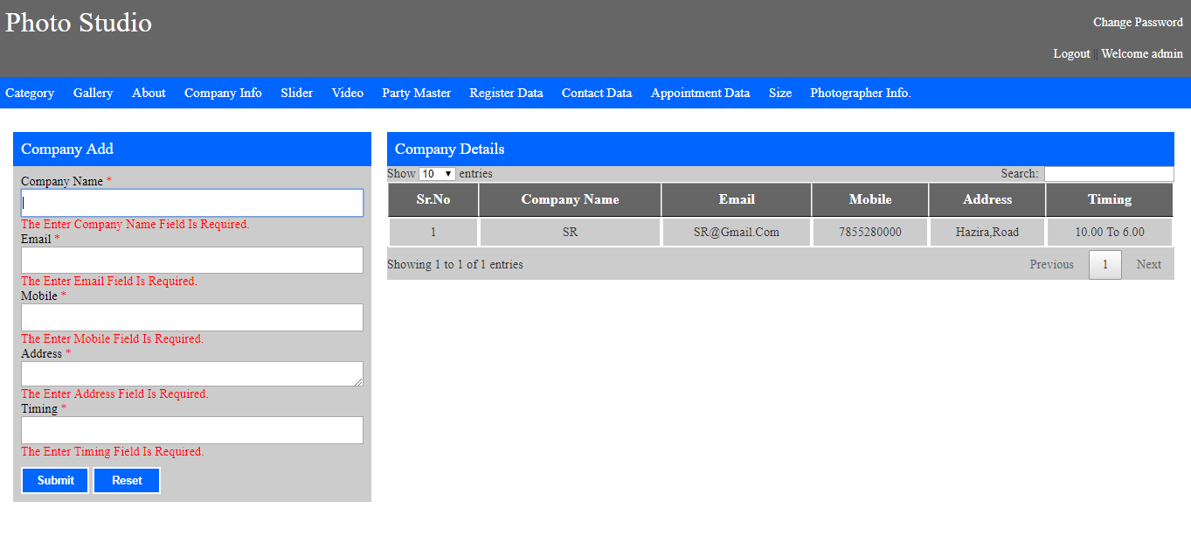

**7. Admin Slider With Validation**

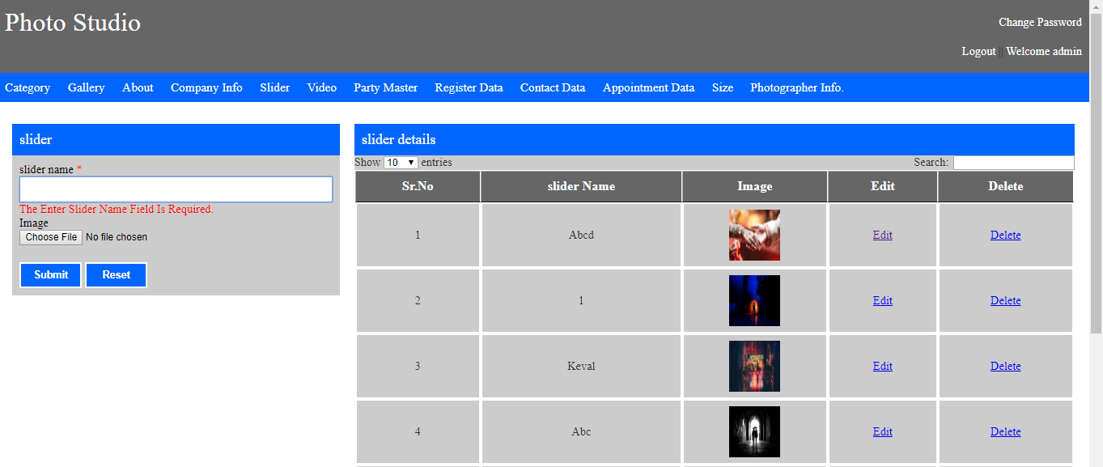

**8. Admin Video With Validation**

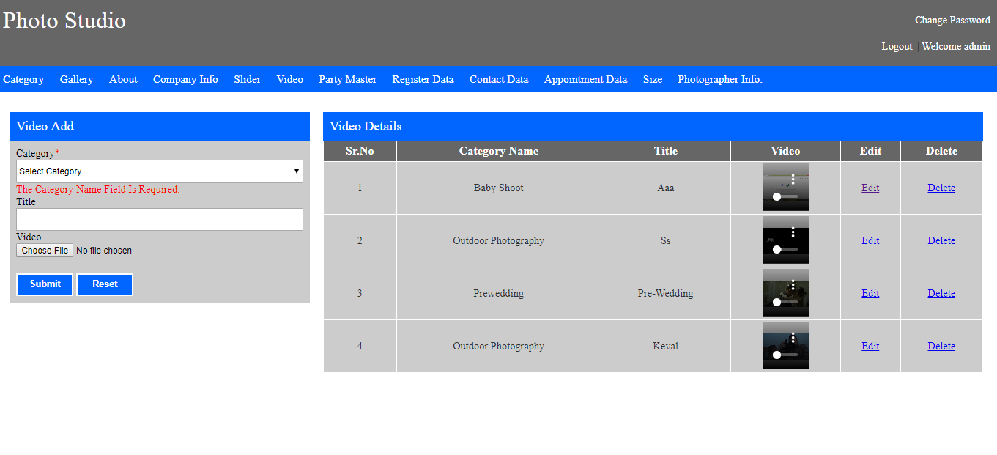

**9. Admin Party Album With Validation**

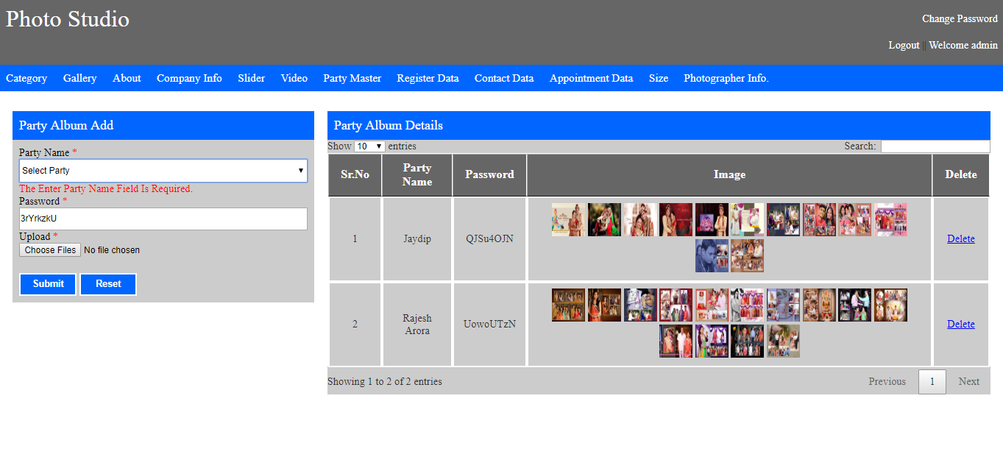

**10. Admin Register Data With Validation**

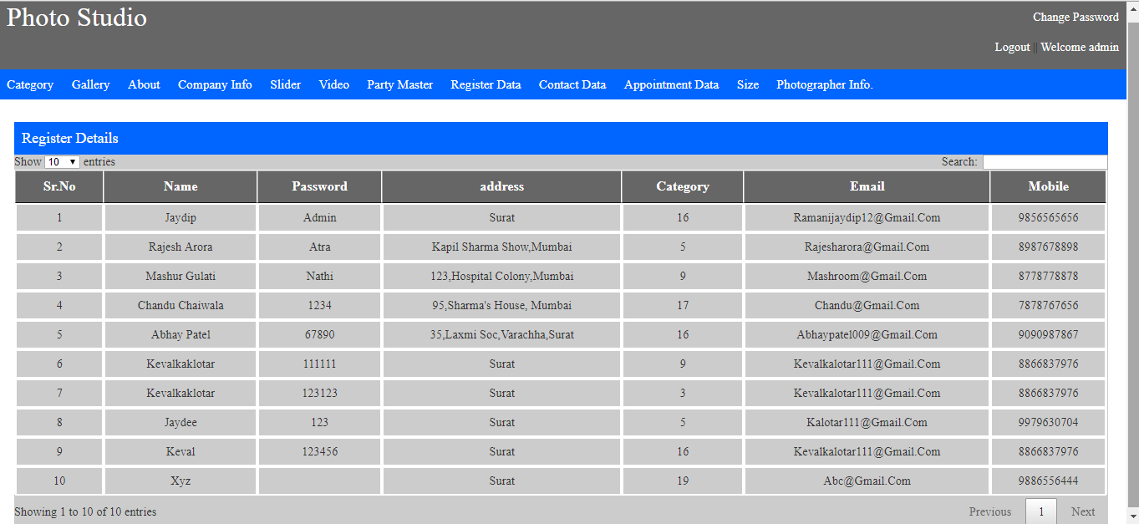

**11. Admin Contact Data With Validation**

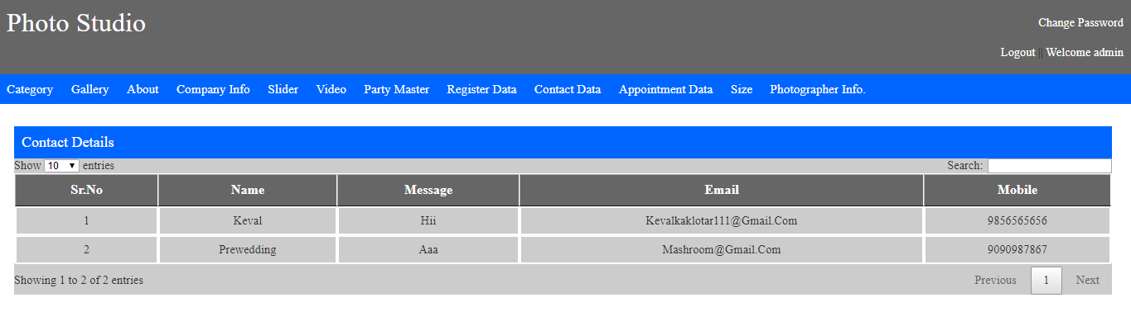

**12. Admin Appointment Data With Validation**

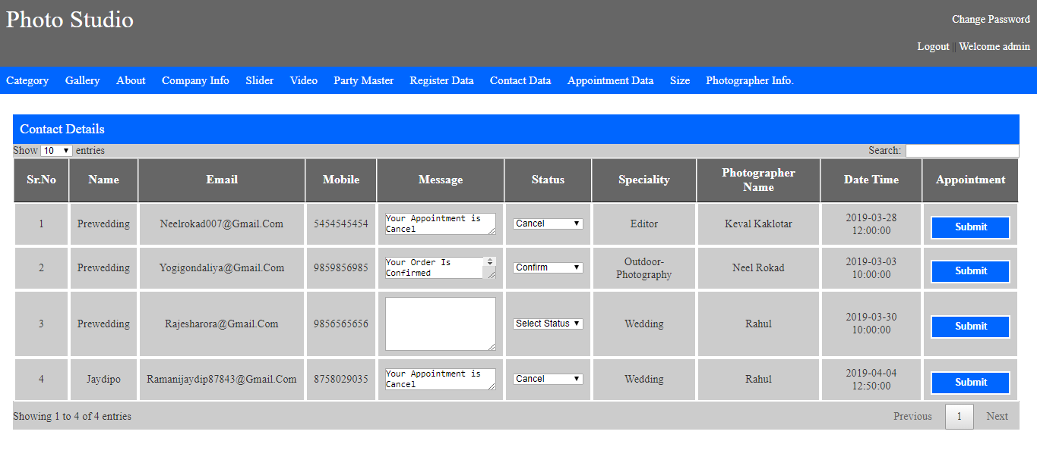

**13. Admin Size With Validation**

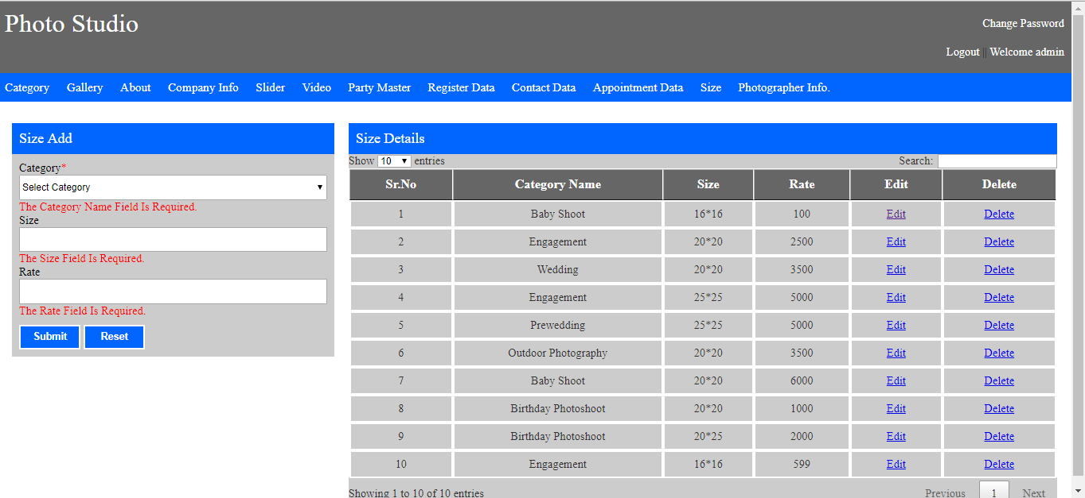

**14. Admin Photographer Info. With Validation**

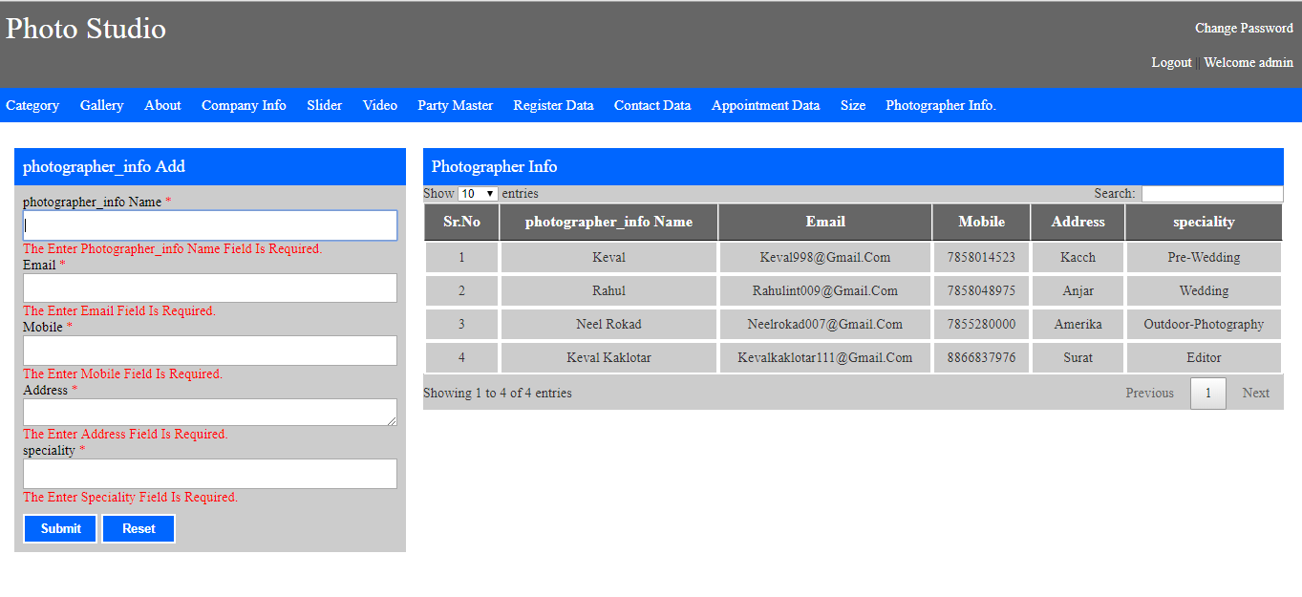

**15. Admin Change Password.**

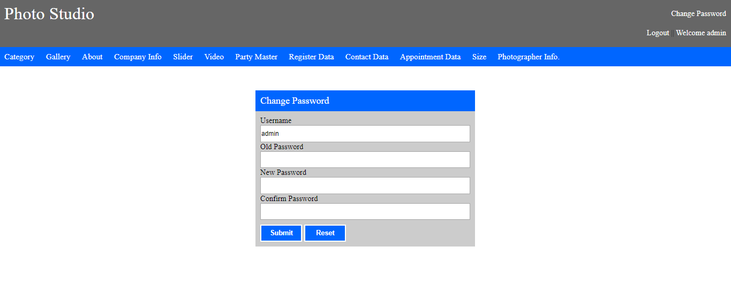

**\* User**

**1. Home Page :**

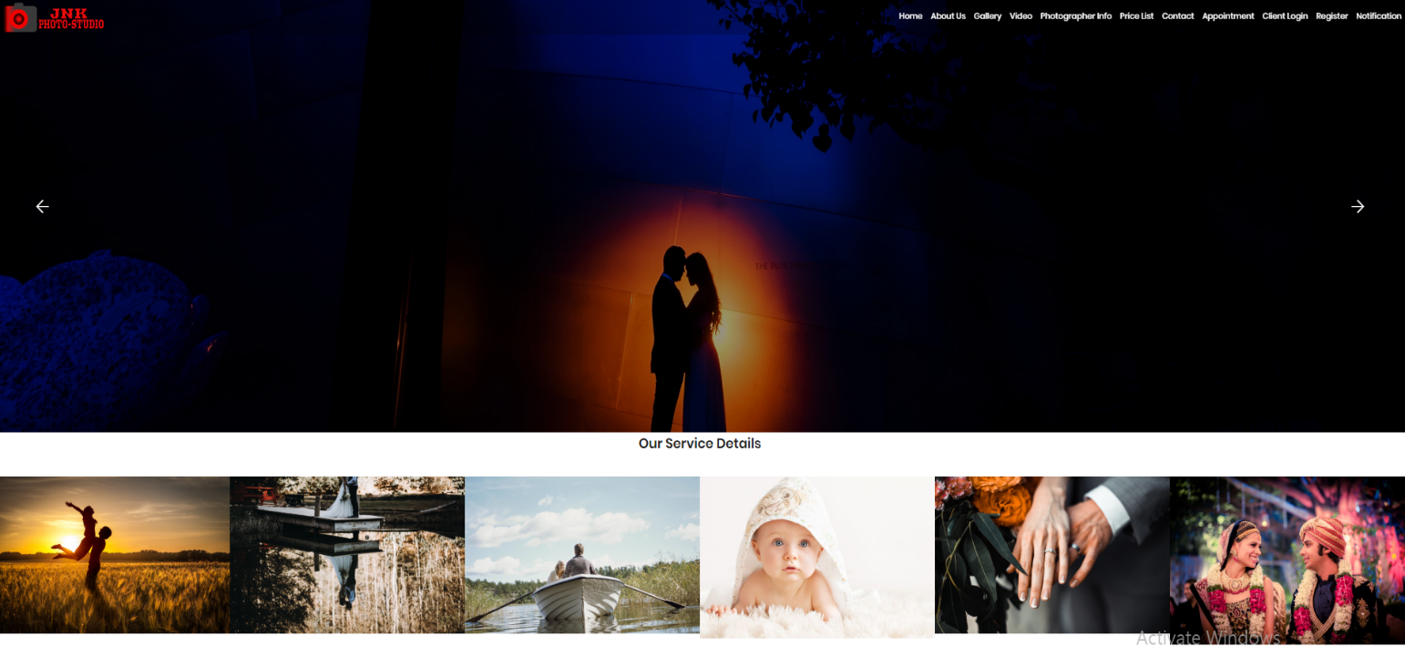

**2. About Us :**

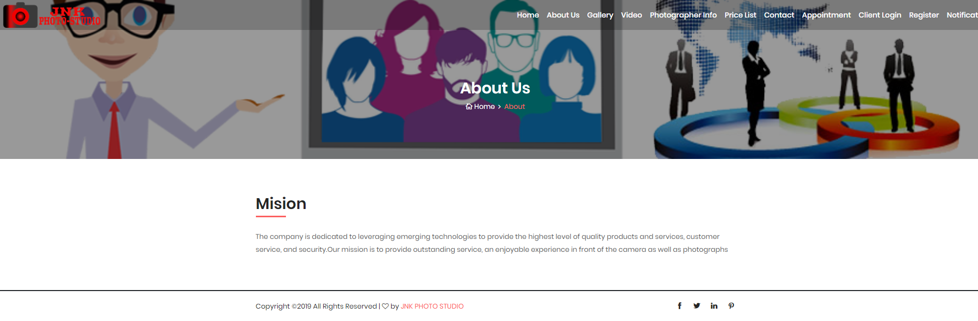

**3. Gallery :**

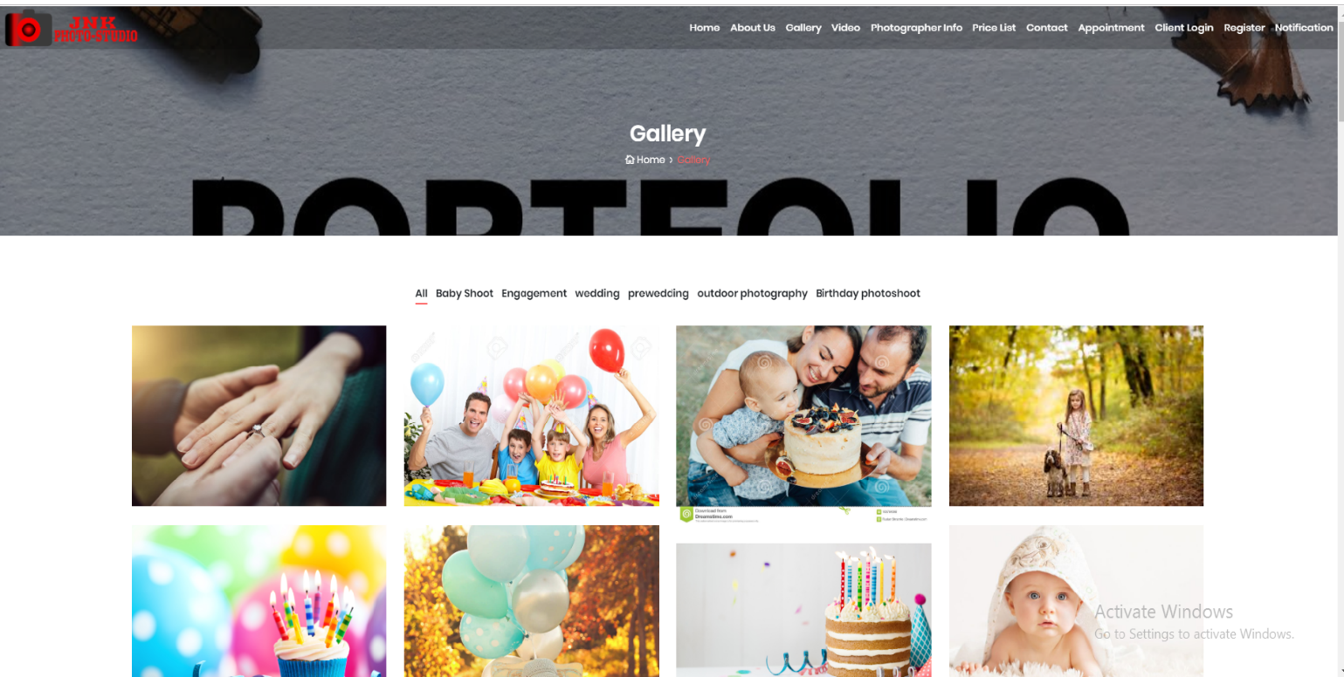

**4. Video :**

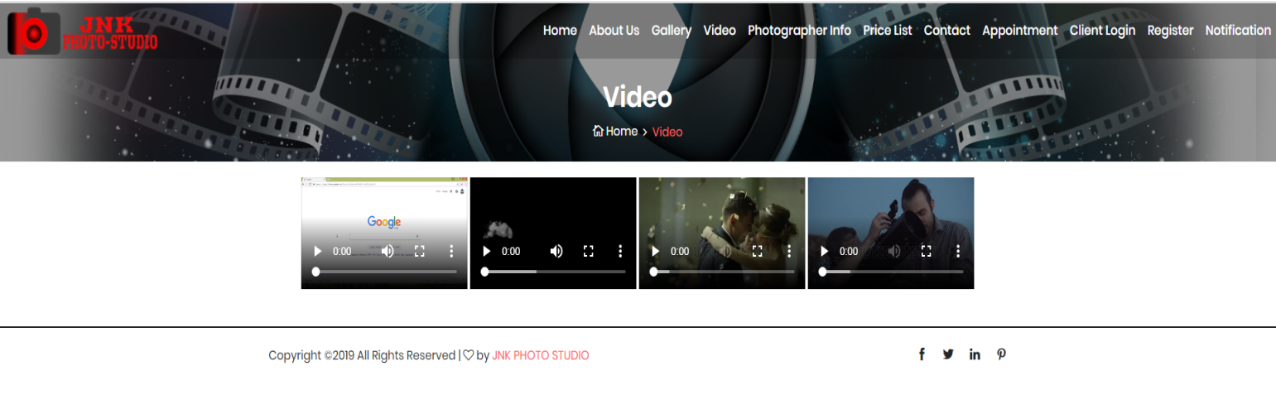

**5. Photographer Info.**

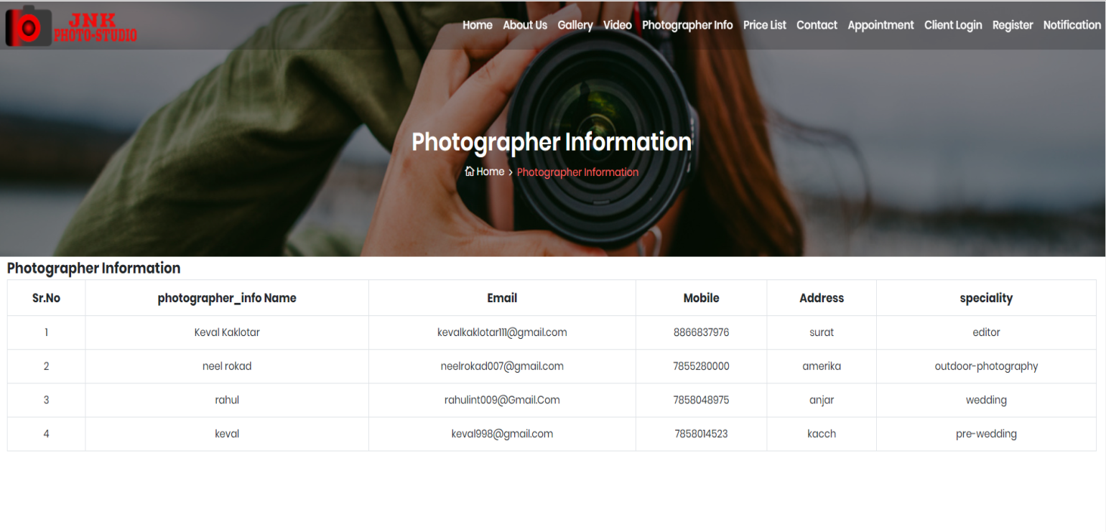

**6. Price-List :**

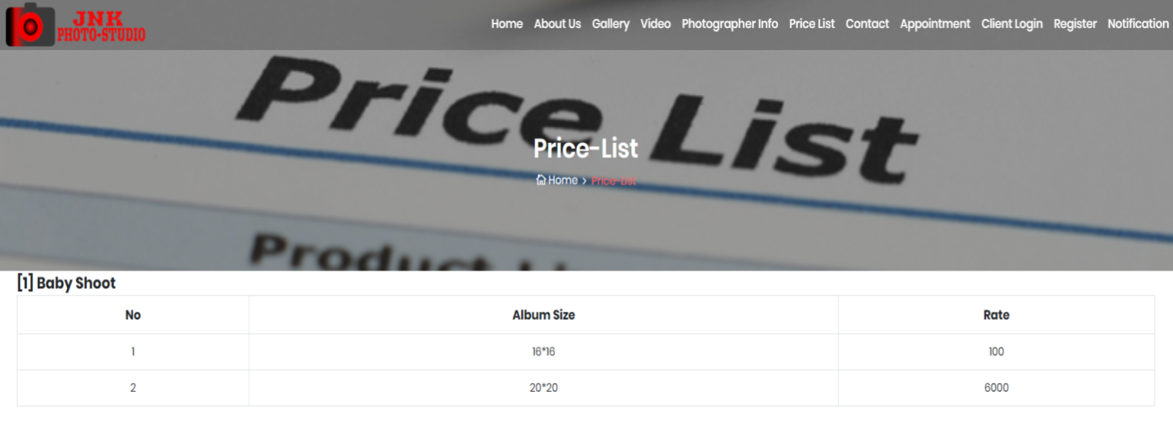

**7. Contact :**

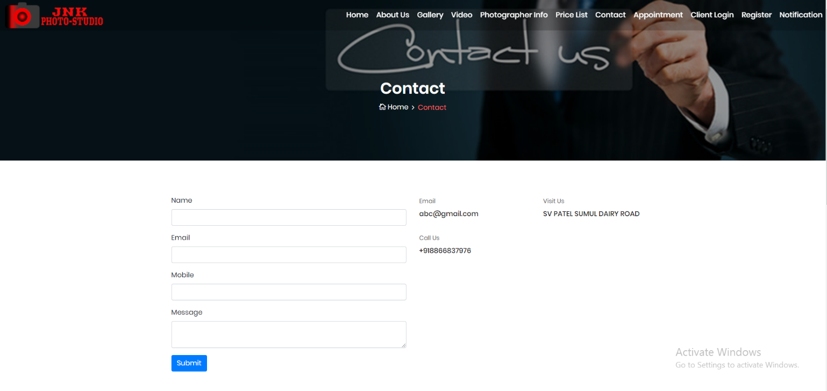

**9. Appointment :**

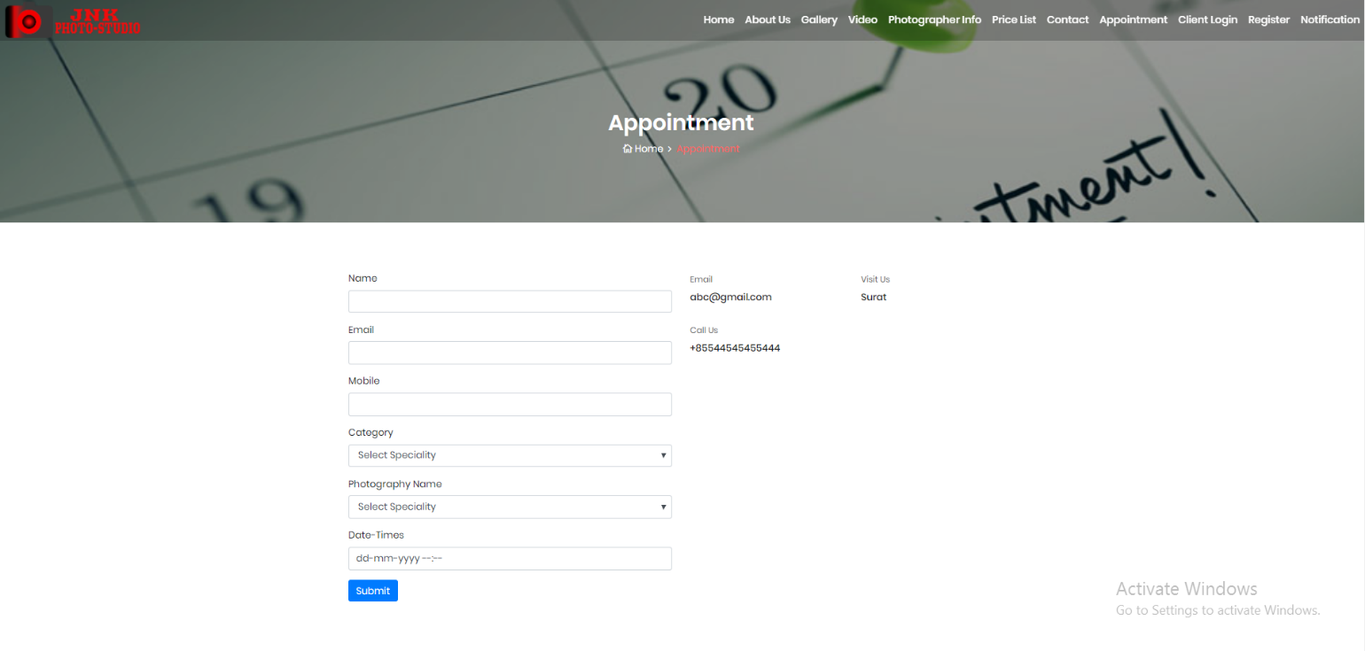

**10. Client Login :**



**11. Register :**

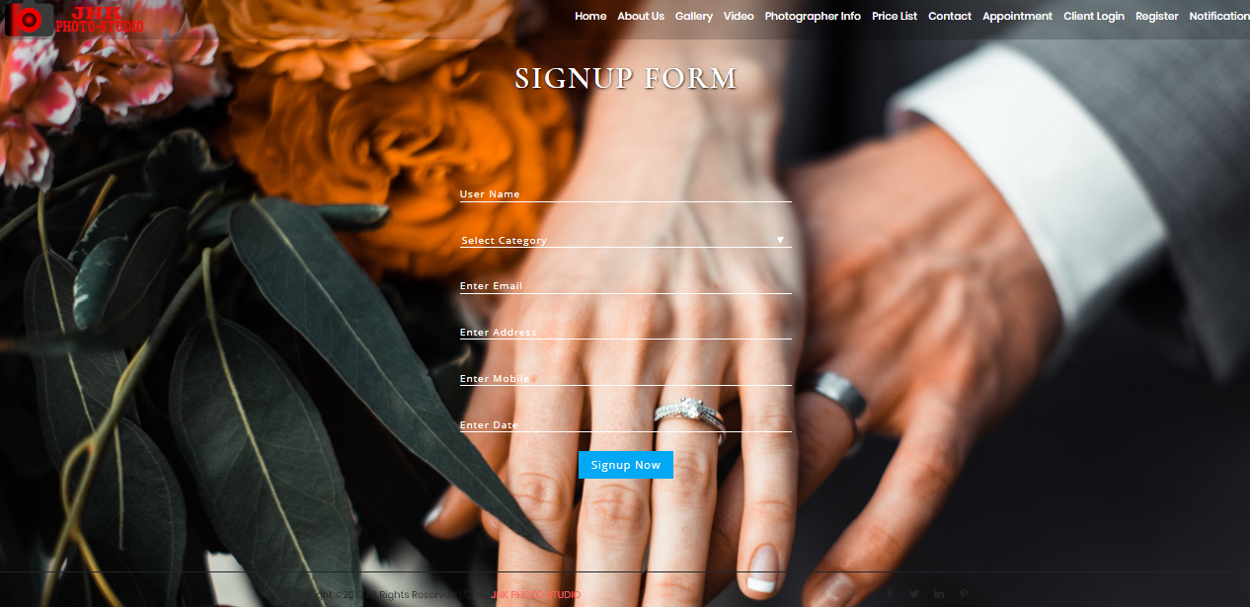

**12. Notification :**

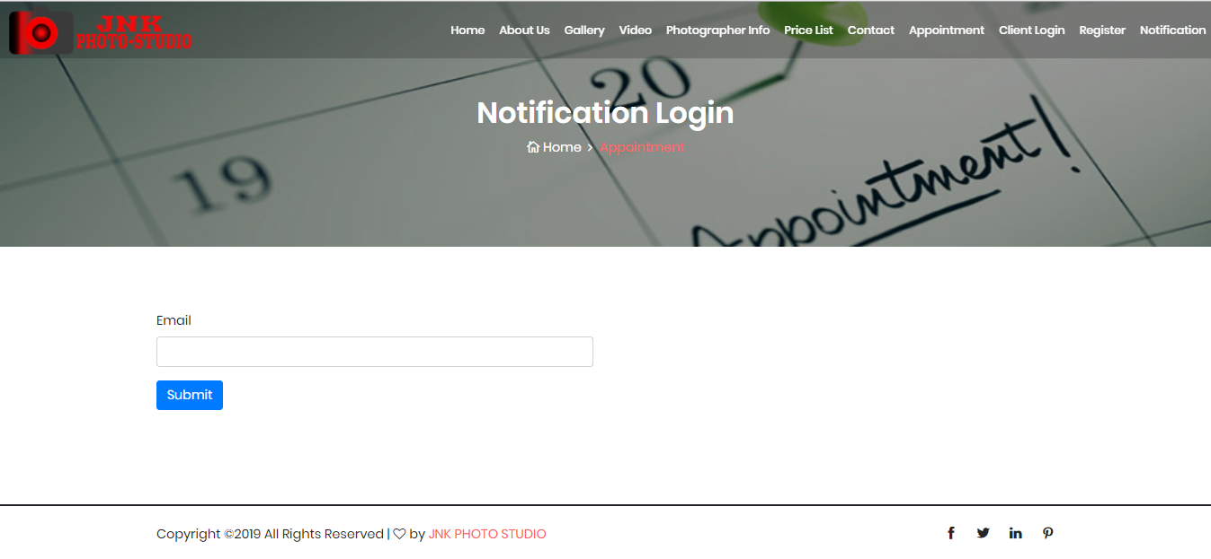

**8. Software Testing**

Software testing is a critical element of software quality assurance and represents the ultimate review of specification design and coding. Testing is an exposure of a system to trial input to see whether software meets correct output. Testing cannot be determined whether software meets user’s needs, only whether it appears to confirm to requirements. Testing can show that a system is free of errors, only that it contains error. Testing finds errors, it does not correct errors. Software success is a quality product, on time and within cost. Through testing can reveal critical mistakes. Testing should therefore,

* Validate Performance.
* Detects errors.
* Identify.
* Inconsistencies.

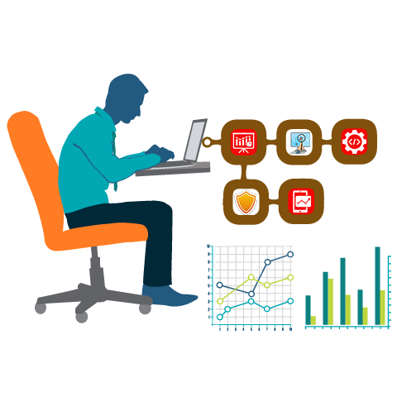

**Test Objective**

There Is Strong Evidence That Effective Requirement Management Leads To Overall Project Cost Savings. The Three Primary Reasons For This Are:

* Errors in requirement typically cost over 10 times more to repair than other errors.
* Requirement errors typically comprise over 40% of all error in a software project.

The Testing Procedure Should Care For All Of These, As Well As, In Order To Attain A Flawless, Error-Free And Efficient Functioning System; Too, Software Testing Is An Important Phase Of Any Software Development Life Cycle. Various Reports And Data Used For The Same Are The Core Of The System. The Testing, Therefore, Becomes Important In Order To Maintain The Cost As Well As Improve Performance And Consistency. The Testing Procedure For The System Has Been Divided In To Various Parts Ranging For Single Unit Testing To Entire System Testing.

**Testing Principles**

* All test should be traceable to customer requirements.
* Tests should be planned long before testing begins.
* The pareto principle applies to software testing.
* Testing should begin “in the small” and progress toward testing “in the large”.
* Exhaustive testing is not possible.
* **Unit Testing**

Unit Testing is a level of software testing where individual units/ components of a software are tested. The purpose is to validate that each unit of the software performs as designed. A unit is the smallest testable part of software. It usually has one or a few inputs and usually a single output.

* **Integration Testing**

**Integration Testing** is a level of software testing where individual units are combined and tested as a group. The purpose of this level of testing is to expose faults in the interaction between integrated units. Test drivers and test stubs are used to assist in Integration Testing.

* **Top-down integration**

Top-down integration testing is an integration testing technique used in order to simulate the behaviour of the lower-level modules that are not yet integrated. Stubs are the modules that act as temporary replacement for a called module and give the same output as that of the actual product.

* **Bottom-down integration**

Bottom-up testing is a specific type of integration testing that tests the lowest components of a code base first. More generally, it refers to a middle phase in software testing that involves taking integrated code units and testing them together, before testing an entire system or code base.

* **Validation Testing**

The process of evaluating software during the development process or at the end of the development process to determine whether it satisfies specified business requirements.

Validation Testing ensures that the product actually meets the client's needs. It can also be defined as to demonstrate that the product fulfills its intended use when deployed on appropriate environment.

* **System Testing**

System testing of software or hardware is testing conducted on a complete, integrated system to evaluate the system's compliance with its specified requirements. System testing falls within the scope of black-box testing, and as such, should require no knowledge of the inner design of the code or logic.

* **Recovery Testing**

Recovery testing is a type of non-functional testing technique performed in order to determine how quickly the system can recove rafter it has gone through system crash or hardware failure. Recovery testing is the forced failure of the software to verify if the recovery is successful.

* **Security Testing**

Security testing is a process intended to reveal flaws in the security mechanisms of an information system that protect data and maintain functionality as intended.

* **Stress Testing**

Stress testing a Non-Functional testing technique that is performed as part of performance testing. During stress testing, the system is monitored after subjecting the system to overload to ensure that the system can sustain the stress.

* **Sanity Testing**

Sanity testing is the subset of regression testing and it is performed when we do not have enough time for doing testing. Sanity testing is the surface level testing where QA engineer verifies that all the menus, functions, commands available in the product and project are working fine.

* **White Box Testing**
* White-box testing (also known as clear box testing, glass box testing, transparent box testing, and structural testing) is a method of testing [software](https://en.wikipedia.org/wiki/Software) that tests internal structures or workings of an application, as opposed to its functionality (i.e. [black-box testing](https://en.wikipedia.org/wiki/Black-box_testing)).
* In white-box testing an internal perspective of the system, as well as programming skills, are used to design test cases.
* The tester chooses inputs to exercise paths through the code and determine the expected outputs.
* This is analogous to testing nodes in a circuit, e.g. [in-circuit testing](https://en.wikipedia.org/wiki/In-circuit_test) (ICT). White-box testing can be applied at the [unit](https://en.wikipedia.org/wiki/Unit_testing), [integration](https://en.wikipedia.org/wiki/Integration_testing) and [system](https://en.wikipedia.org/wiki/System_testing) levels of the [software testing](https://en.wikipedia.org/wiki/Software_testing)process.
* Although traditional testers tended to think of white-box testing as being done at the unit level, it is used for integration and system testing more frequently today.
* It can test paths within a unit, paths between units during integration, and between subsystems during a system–level test.
* Though this method of test design can uncover many errors or problems, it has the potential to miss unimplemented parts of the specification or missing requirements.

**9. Limitation and System Enhancement**

## Limitation of System

## Albumcannot physical touchable.

## Internet must be required for use this system.

## Registration should be required for use this system.

**10. Bibliography**

## References :

## <http://www.weddingnama.in/>

## <https://shitalphoto.com/>

## <https://www.phototantra.com/>

## <http://www.ramitbatra.com/>

## <http://www.shutterdown.in/>